

Know Your TX – Dissecting a Transaction



**Objective/Aim:**  
  
 To understand how a transaction takes place in a blockchain environment and how to inspect its details using tools like MetaMask and Etherscan.

**Apparatus/Software Used:**

* Laptop
* Brave Browser
* Ethereum sepolia faucet
* Etherscan (Sepolia Network)

**Theory/Concept:**

**What Is a Blockchain Transaction (TX)?**

A blockchain transaction is a record of data change on the blockchain. It can include

* Value transfers – Sending cryptocurrency from one account to another.
* Interacting with a smart contract.
* State updates – Recording new information in the blockchain’s public ledger.



**Procedure:**

|  |  |  |  |
| --- | --- | --- | --- |
|  |  |  |  |
|  |  |  |  |
|  |  |  |  |
|  |  |  |  |
|  |  |  |  |
|  |  |  |  |
|  |  |  |  |

**Step 1: Open your Sepolia Ethereum wallet**

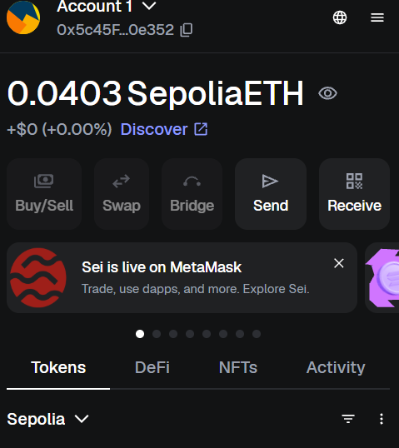

**Step 2: Then go to Google Cloud Ethereum Sopelia faucet**

**Step 3: Copy paste your sopelia Ethereum account number and Receive 0.05 Sopelia ETH within few minute**

**Step 4: Open ETHERSCAN for view the transation made in your account**

**Step 5: Search your account number it will show all the transaction details**

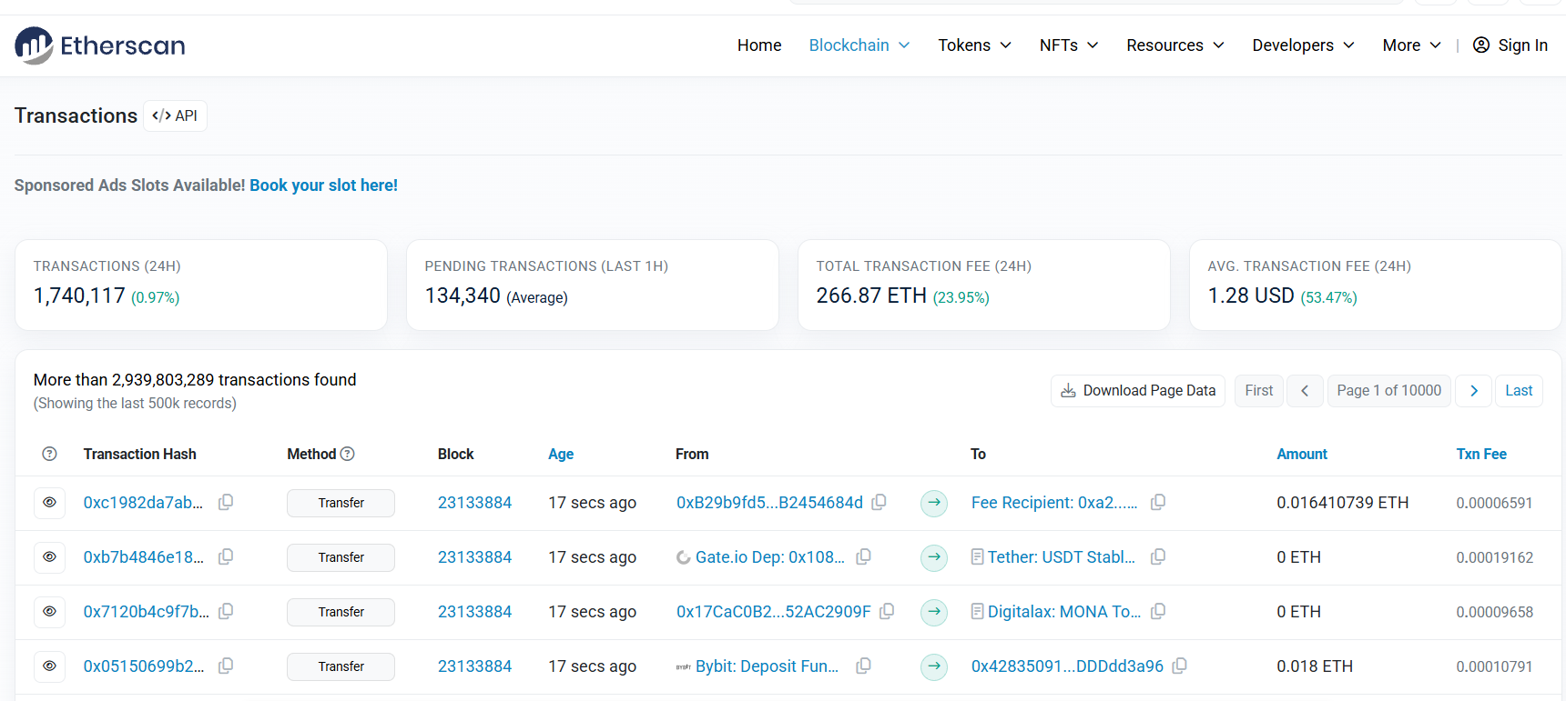

**Observation Table:**

|  |  |
| --- | --- |
| **Step** | **Observation** |
| 1 | Wallet address copied and pasted in Sepolia Faucet |
| 2 | ETH request submitted successfully |
| 3 | 0.05 Sepolia ETH received in MetaMask wallet after ~2–3 minutes |
| 4 | Transaction verified on Sepolia Etherscan with status “Success” |
| 5 | All transaction details (hash, sender, recipient, block number, gas fees) visible on Etherscan |

.

